MAHENDRA ENGINEERING COLLEGE FOR WOMEN
ASSIGNMENT-2 SOLUTION
NAME OF THE STUDENT:V.Hemalatha
REGISTER NUMBER:611419106029
YEAR/DEPARTMENT:1V-ECE
/data/user/0/com.microsoft.office.word/app_EmailAttachments2fd50a3f-d92b-4d15-b6e3-26f436f53ac3/DOC-20220926-WA0004..pdf#libraries
import pandas as pd import numpy as np
import matplotlib.pyplot as plt
%matplotlib inline
#load dataset
df = pd.read_csv(r"/content/Churn_Modelling.csv") df.head(10)
\ | RowNumber |  | CustomerId |  | Surname | CreditScore | Geography | Gender |  | Age
0 | 1 |  | 15634602 |  | Hargrave | 619 | France | Female |  | 42
1 | 2 |  | 15647311 |  | Hill | 608 | Spain | Female |  | 41
2 | 3 |  | 15619304 |  | Onio | 502 | France | Female |  | 42
3 | 4 |  | 15701354 |  | Boni | 699 | France | Female |  | 39
4 | 5 |  | 15737888 |  | Mitchell | 850 | Spain | Female |  | 43
5 | 6 |  | 15574012 |  | Chu | 645 | Spain | Male |  | 44
6 | 7 |  | 15592531 |  | Bartlett | 822 | France | Male |  | 50
7 | 8 |  | 15656148 |  | Obinna | 376 | Germany | Female |  | 29
8 | 9 |  | 15792365 |  | He | 501 | France | Male |  | 44
9 | 10 |  | 15592389 |  | H? | 684 | France | Male |  | 27
 | Tenure | Balance |  | NumOfProducts |  | HasCrCard | IsActiveMember |  | \
0 | 2 | 0.00 |  | 1 |  | 1 | 1
1 | 1 | 83807.86 |  | 1 |  | 0 | 1
2 | 8 | 159660.80 |  | 3 |  | 1 | 0
3 | 1 | 0.00 |  | 2 |  | 0 | 0
4 | 2 | 125510.82 |  | 1 |  | 1 | 1
5 | 8 | 113755.78 |  | 2 |  | 1 | 0
6 | 7 | 0.00 |  | 2 |  | 1 | 1
7 | 4 | 115046.74 |  | 4 |  | 1 | 0
8 | 4 | 142051.07 |  | 2 |  | 0 | 1
9 | 2 | 134603.88 |  | 1 |  | 1 | 1
 | EstimatedSalary |  |  | Exited
0 | 101348.88 |  |  | 1
1 | 112542.58 |  |  | 0
2 | 113931.57 |  |  | 1

3 | 93826.63 | 0
4 | 79084.10 | 0
5 | 149756.71 | 1
6 | 10062.80 | 0
7 | 119346.88 | 1
8 | 74940.50 | 0
9  df.info() | 71725.73 | 0

<class 'pandas.core.frame.DataFrame'> RangeIndex: 10000 entries, 0 to 9999 Data columns (total 14 columns):
# Column Non-Null Count Dtype
- RowNumber 10000 non-null int64
- CustomerId 10000 non-null int64
- Surname 10000 non-null object
- CreditScore 10000 non-null int64
- Geography 10000 non-null object
- Gender 10000 non-null object
- Age 10000 non-null int64
- Tenure 10000 non-null int64
- Balance 10000 non-null float64
- NumOfProducts 10000 non-null int64
- HasCrCard 10000 non-null int64
- IsActiveMember 10000 non-null int64
- EstimatedSalary 10000 non-null float64
- Exited 10000 non-null int64 dtypes: float64(2), int64(9), object(3) memory usage: 1.1+ MB
#Visualizations #Univariate Analysis import seaborn as sns

sns.kdeplot(df['CreditScore'])
<matplotlib.axes._subplots.AxesSubplot at 0x7fc4a0cd2790>

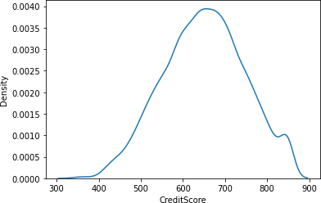

#Bi - Variate Analysis

plt.bar(df.CustomerId, df.CreditScore) plt.title('CreditScore') plt.xlabel('CustomerId') plt.ylabel('CreditScore')
Text(0, 0.5, 'CreditScore')

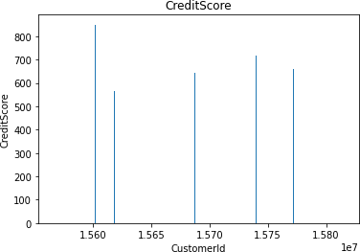

sns.lmplot(x='Tenure', y='Balance', data=df ,hue='Exited',size=8)
/usr/local/lib/python3.7/dist-packages/seaborn/regression.py:581: UserWarning: The `size` parameter has been renamed to `height`; please update your code.
warnings.warn(msg, UserWarning)
<seaborn.axisgrid.FacetGrid at 0x7fc4a149e2d0>
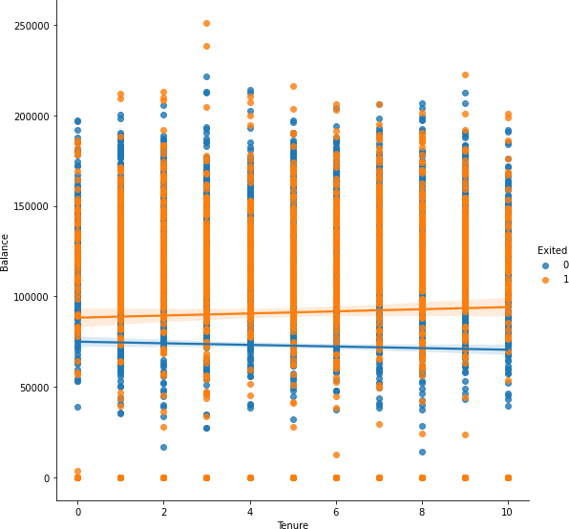

#Multi - Variate Analysis
ax = df[["CreditScore","Age","Tenure","Balance"]].plot(figsize=(80,40)) ax.legend(loc='center left', bbox_to_anchor=(1, 0.5));
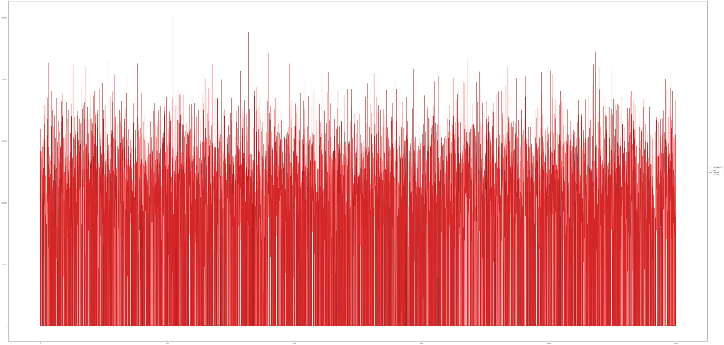

df.isnull().sum()
RowNumber 0
CustomerId 0
Surname 0
CreditScore 0
Geography 0
Gender 0
Age 0
Tenure 0
Balance 0
NumOfProducts 0
HasCrCard 0
IsActiveMember 0
EstimatedSalary 0
Exited 0
dtype: int64
plt.figure(figsize=(15,13)) sns.heatmap(df.corr(),annot=True,cmap='BuPu') plt.show()
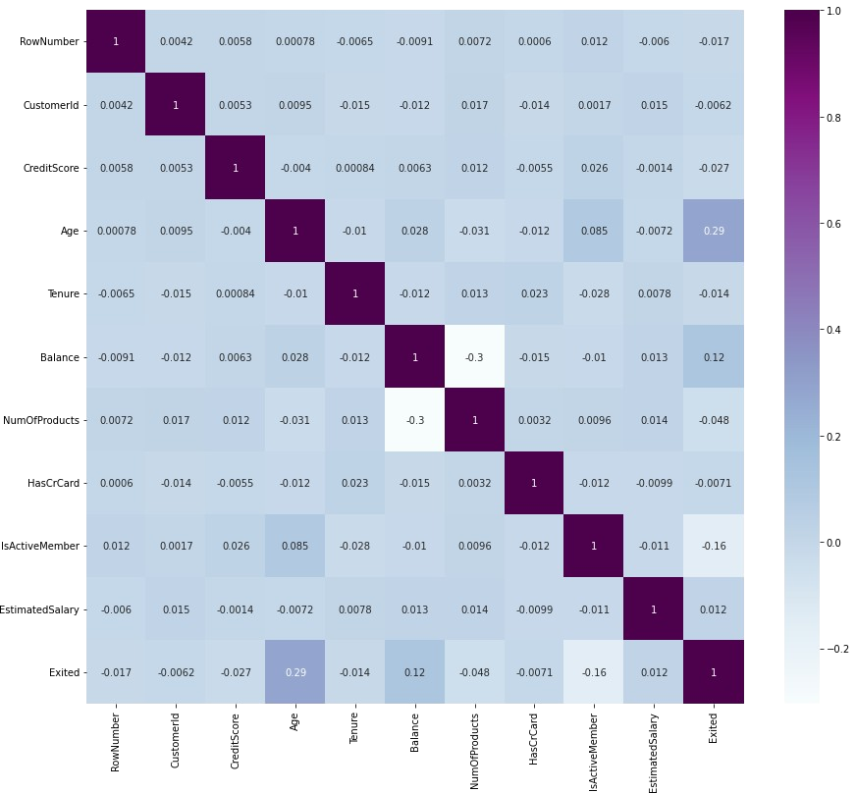

df.drop(['RowNumber', 'CustomerId','Surname'],axis=1,inplace=True) df.head()
CreditScore  NumOfProducts |  | Geography  \ | Gender | Age | Tenure | Balance
0 | 619 | France | Female | 42 | 2 | 0.00
1
1 | 608 | Spain | Female | 41 | 1 | 83807.86
1
2 | 502 | France | Female | 42 | 8 | 159660.80
3
3 | 699 | France | Female | 39 | 1 | 0.00
2
4 | 850 | Spain | Female | 43 | 2 | 125510.82
1

HasCrCard IsActiveMember EstimatedSalary Exited 0 1 1 101348.88 1
1 | 0 | 1 | 112542.58 | 0
2 | 1 | 0 | 113931.57 | 1
3 | 0 | 0 | 93826.63 | 0
4  df.info() | 1 | 1 | 79084.10 | 0
<class 'pandas.core.frame.DataFrame'> RangeIndex: 10000 entries, 0 to 9999 Data columns (total 11 columns):
# Column Non-Null Count Dtype
- CreditScore 10000 non-null int64
- Geography 10000 non-null object
- Gender 10000 non-null object
- Age 10000 non-null int64
- Tenure 10000 non-null int64
- Balance 10000 non-null float64
- NumOfProducts 10000 non-null int64
- HasCrCard 10000 non-null int64
- IsActiveMember 10000 non-null int64
- EstimatedSalary 10000 non-null float64
- Exited 10000 non-null int64 dtypes: float64(2), int64(7), object(2) memory usage: 859.5+ KB
df["Geography"].unique()
array(['France', 'Spain', 'Germany'], dtype=object) df["Gender"].unique()
array(['Female', 'Male'], dtype=object) geo=pd.get_dummies(df["Geography"],drop_first=False) geo.head()
France Germany Spain 0 1 0 0
1 0 0 1
2 1 0 0
3 1 0 0
4 0 0 1
gen=pd.get_dummies(df["Gender"],drop_first=False) df=pd.concat([df, geo,gen], axis=1)
df
CreditScore Geography Gender Age Tenure Balance NumOfProducts \
0 | 619 | France | Female | 42 | 2 | 0.00
1
1 | 608 | Spain | Female | 41 | 1 | 83807.86
1
2 | 502 | France | Female | 42 | 8 | 159660.80
3
3 | 699 | France | Female | 39 | 1 | 0.00
2
4 | 850 | Spain | Female | 43 | 2 | 125510.82
1
... | ... | ... | ... | ... | ... | ...
...
9995 | 771 | France | Male | 39 | 5 | 0.00
2
9996 | 516 | France | Male | 35 | 10 | 57369.61
1
9997 | 709 | France | Female | 36 | 7 | 0.00
1
9998 | 772 | Germany | Male | 42 | 3 | 75075.31
2
9999 | 792 | France | Female | 28 | 4 | 130142.79
1

HasCrCard IsActiveMember EstimatedSalary Exited France Germany \
0 | 1 |  | 1 | 101348.88 | 1 | 1
0
1 | 0 |  | 1 | 112542.58 | 0 | 0
0
2 | 1 |  | 0 | 113931.57 | 1 | 1
0
3 | 0 |  | 0 | 93826.63 | 0 | 1
0
4 | 1 |  | 1 | 79084.10 | 0 | 0
0  ...  ... 9995 | ...  1 |  | ...  0 | ... 96270.64 | ...  0 | ...  1
0
9996 | 1 |  | 1 | 101699.77 | 0 | 1
0
9997 | 0 |  | 1 | 42085.58 | 1 | 1
0
9998 | 1 |  | 0 | 92888.52 | 1 | 0
1
9999 | 1 |  | 0 | 38190.78 | 0 | 1
0
0 | Spain  0 | Female  1 | Male  0

1 | 1 | 1 | 0
2 | 0 | 1 | 0
3 | 0 | 1 | 0
4 | 1 | 1 | 0
... | ... | ... | ...
9995 | 0 | 0 | 1
9996 | 0 | 0 | 1
9997 | 0 | 1 | 0
9998 | 0 | 0 | 1
9999 | 0 | 1 | 0

[10000 rows x 16 columns] df.drop(["Geography","Gender"], axis=1, inplace=True) df.head()
CreditScore Age Tenure Balance NumOfProducts HasCrCard \ 0 619 42 2 0.00 1 1
1 608 41 1 83807.86 1 0
2 502 42 8 159660.80 3 1
3 699 39 1 0.00 2 0
4 850 43 2 125510.82 1 1

IsActiveMember EstimatedSalary Exited France Germany Spain Female \
0 |  | 1 | 101348.88 | 1 | 1 | 0 | 0
1
1 |  | 1 | 112542.58 | 0 | 0 | 0 | 1
1
2 |  | 0 | 113931.57 | 1 | 1 | 0 | 0
1
3 |  | 0 | 93826.63 | 0 | 1 | 0 | 0
1
4 |  | 1 | 79084.10 | 0 | 0 | 0 | 1
1
0 | Male  0
1 | 0
2 | 0
3 | 0
4 | 0
x=df.drop('Exited',axis=1) x
 | CreditScore | Age | Tenure | Balance | NumOfProducts | HasCrCard | \
0 | 619 | 42 | 2 | 0.00 | 1 | 1
1 | 608 | 41 | 1 | 83807.86 | 1 | 0

2 | 502 | 42 | 8 | 159660.80 |  | 3 | 1
3 | 699 | 39 | 1 | 0.00 |  | 2 | 0
4 | 850 | 43 | 2 | 125510.82 |  | 1 | 1
... | ... | ... | ... | ... |  | ... | ...
9995 | 771 | 39 | 5 | 0.00 |  | 2 | 1
9996 | 516 | 35 | 10 | 57369.61 |  | 1 | 1
9997 | 709 | 36 | 7 | 0.00 |  | 1 | 0
9998 | 772 | 42 | 3 | 75075.31 |  | 2 | 1
9999 | 792 | 28 | 4 | 130142.79 |  | 1 | 1
Male | IsActiveMember |  | EstimatedSalary |  | France | Germany | Spain | Female
0 | 1 |  | 101348.88 |  | 1 | 0 | 0 | 1
0
1 | 1 |  | 112542.58 |  | 0 | 0 | 1 | 1
0
2 | 0 |  | 113931.57 |  | 1 | 0 | 0 | 1
0
3 | 0 |  | 93826.63 |  | 1 | 0 | 0 | 1
0
4 | 1 |  | 79084.10 |  | 0 | 0 | 1 | 1
0  ...  ... 9995 | ...  0 |  | ... 96270.64 |  | ...  1 | ...  0 | ...  0 | ...  0
1
9996 | 1 |  | 101699.77 |  | 1 | 0 | 0 | 0
1
9997 | 1 |  | 42085.58 |  | 1 | 0 | 0 | 1
0
9998 | 0 |  | 92888.52 |  | 0 | 1 | 0 | 0
1
9999 | 0 |  | 38190.78 |  | 1 | 0 | 0 | 1
0

[10000 rows x 13 columns] y=df['Exited']
y

0 | 1
1 | 0
2 | 1
3 | 0
4 | 0
 | ..
9995 | 0
9996 | 0
9997 | 1
9998 | 1

9999 0
Name: Exited, Length: 10000, dtype: int64 df.shape
(10000, 14)
x.shape (10000, 13)
y.shape (10000,)
from sklearn.model_selection import train_test_split
x_train,x_test, y_train,y_test = train_test_split(x,y, test_size=0.2,random_state=0)
x_train.shape (8000, 13)
x_test.shape (2000, 13)
y_test.shape (2000,)
from sklearn.preprocessing import StandardScaler sc = StandardScaler()
x_train = sc.fit_transform(x_train) x_train
array([[ 0.16958176, | -0.46460796, 0.00666099, |  | ..., | 1.74309049,
1.09168714, | -1.09168714],
[-2.30455945, | 0.30102557, -1.37744033, |  | ..., | -0.57369368,
-0.91601335, | 0.91601335],
[-1.19119591, | -0.94312892, -1.031415 | , | ..., | -0.57369368,
1.09168714,  ..., | -1.09168714],
[ 0.9015152 , | -0.36890377, 0.00666099, |  | ..., | -0.57369368,
-0.91601335, | 0.91601335],
[-0.62420521, | -0.08179119, 1.39076231, |  | ..., | 1.74309049,
1.09168714, | -1.09168714],
[-0.28401079, | 0.87525072, -1.37744033, |  | ..., | -0.57369368,
1.09168714, | -1.09168714]])
x_test = sc.transform(x_test)
x_test
array([[-0.55204276, -0.36890377, 1.04473698, ..., -0.57369368,
1.09168714, -1.09168714],
[-1.31490297, | 0.10961719, -1.031415 | , | ..., | -0.57369368,
1.09168714, | -1.09168714],
[ 0.57162971, | 0.30102557, 1.04473698, |  | ..., | 1.74309049,
1.09168714,  ...,  [-0.74791227, | -1.09168714],  -0.27319958, -1.37744033, |  | ..., | 1.74309049,
-0.91601335, | 0.91601335],
[-0.00566991, | -0.46460796, -0.33936434, |  | ..., | -0.57369368,
-0.91601335, | 0.91601335],
[-0.79945688, | -0.84742473, 1.04473698, |  | ..., | -0.57369368,
-0.91601335, | 0.91601335]])

